SELECT *

FROM bill

JOIN product ON product_id = product.id

JOIN category ON category_id = category.id;

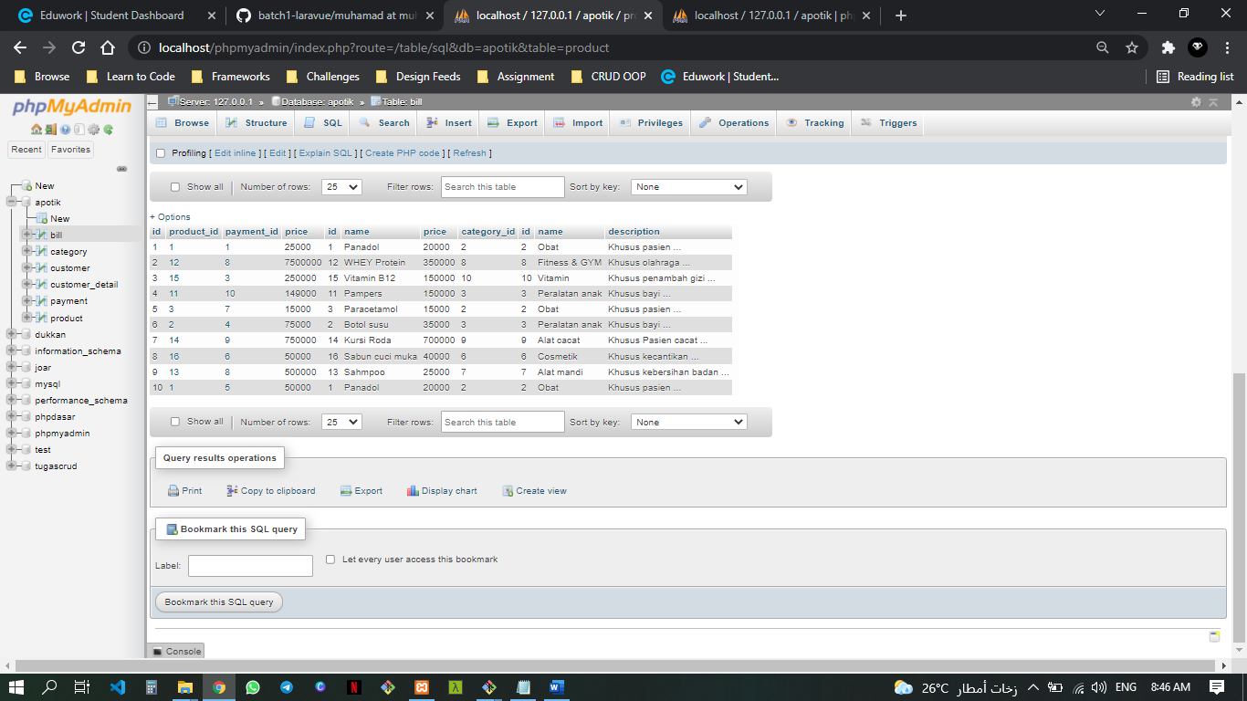

SELECT *

FROM customer_detail

JOIN customer ON customer_id = customer.id

JOIN payment ON customer.id = payment.customer_id;

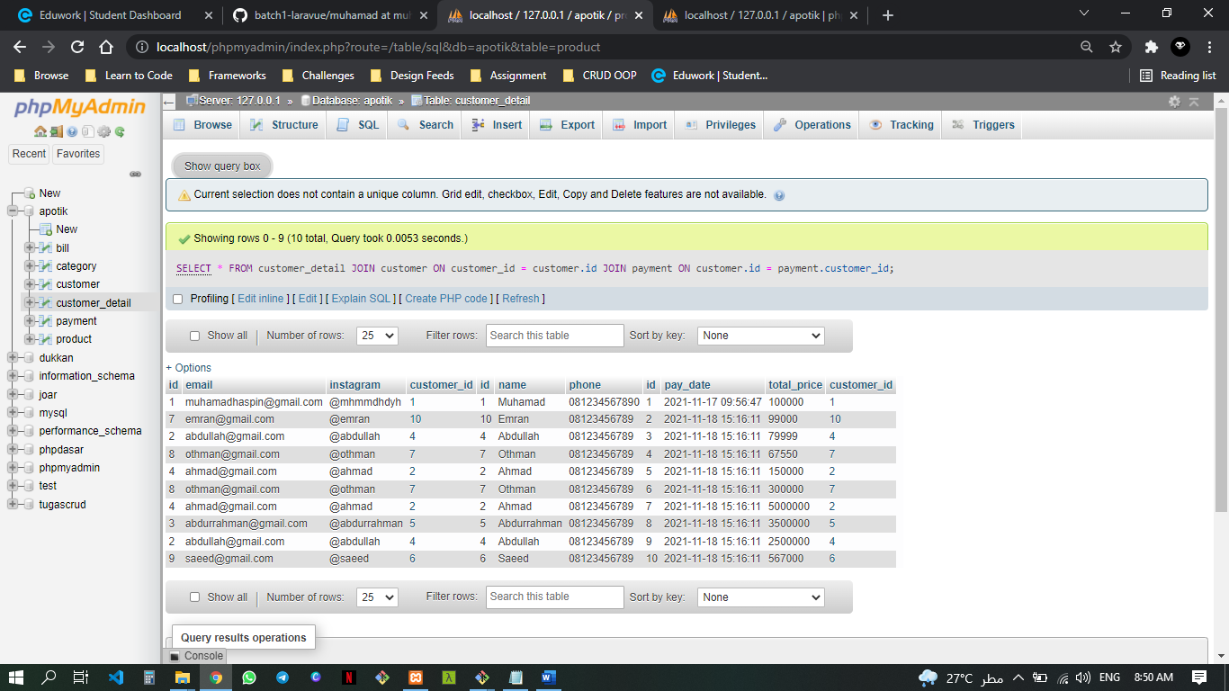

SELECT *

FROM payment

JOIN customer ON customer_id = customer.id

JOIN bill ON payment.id = payment_id;

